 | 26.2 Editors - Properties Editor - Render Properties Tab
Table of content
Detailed Table of content 1
Render Tab 6
Sampling panel 7
Light Paths panel 12
Volumes panel 15
Curves panel 15
Simplify panel 16
Motion Blur panel 18
Film panel 19
Performance panel 20
Bake panel 22

Detailed Table of content

Detailed table of content
Detailed Table of content 1
Render Tab 6
Cycles Feature Set 6
Cycles Device 6
Open Shading Language 6
Sampling panel 7
Viewport subpanel 7
Presets 7
Adaptive Sampling 7
Adaptive sampling threshold 7
Max Samples 7
Min Samples 7
Samples 7
Denoise Sub Subpanel 7
Use Denoising Checkbox 7
Denoiser 8
Automatic 8
OptiX 8
OpenImageDenoiser 8
Passes 8
Start Sample 8
Render subpanel 8
Presets 8
Adaptive sampling threshold 8
Max Samples 8
Min Samples 8
Samples 9
Time Limit 9
Denoise Sub Subpanel 9
Use Denoising Checkbox 9
Denoiser 9
OptiX 9
Passes 9
OpenImageDenoiser 9
Passes 9
Prefilter 9
Quality 9
Use GPU 9
Path Guiding subpanel 10
Training Samples 10
Surface 10
Volume 10
Lights subpanel 10
Light Tree 10
Light Threshold 10
Advanced subpanel 10
Pattern 10
Automatic 10
Classic 11
Blue Noise 11
Seed 11
Animate Seed 11
Sample Offset 11
Scrambling Distance 11
Adaptive 11
Viewport 11
Multiplier 12
Min Light Bounces 12
Min Transparent Bounces 12
Light Paths panel 12
Presets 12
Max Bounces 12
Total 12
Diffuse 13
Glossy 13
Transmission Bounces 13
Volume 13
Transparent 13
Clamping 13
Direct Light 13
Indirect Light 13
Caustics 13
Filter Glossy 13
Reflective Caustics 14
Refractive Caustics 14
Fast GI approximation subpanel 14
Fast GI Approximation checkbox 14
Method 14
Replace 14
AO Factor 14
AO Distance 14
Viewport Bounces 14
Render Bounces 14
Add 14
AO Factor 15
AO Distance 15
Volumes panel 15
Step Rate Render 15
Step Rate Viewport 15
Max Steps 15
Curves panel 15
Shape 15
Curve Subdivisions 15
Viewport Display subpanel 16
Shape 16
Additional Subdiv 16
Simplify panel 16
Enable 16
Viewport 16
Max Subdivisions 16
Child Particles 16
Texture Limit 16
AO Bounces 16
Volume Resolution 16
Render 17
Max Subdivisions 17
Child Particles 17
Texture Limit 17
Culling 17
Use Camera Cull 17
Camera cull margin 17
Use Distance Cull 17
Distance 17
Grease Pencil 17
Playback Only 17
Fill 17
Modifiers 18
Shader Effects 18
Layers Tinting 18
Antialiasing 18
Motion Blur panel 18
Enable 18
Position 18
Shutter 18
Rolling Shutter 18
Duration 18
Shutter Curve 19
Navigation elements 19
Zoom in and out 19
Tools 19
Reset View 19
Vector Handle 19
Auto Handle 19
Auto Clamped Handle 19
Extend Horizontal 19
Extend Extrapolated 19
Reset Curve 19
Use Clipping 19
Delete Points 19
X and Y values 19
Presets 20
Film panel 20
Exposure 20
Pixel Filter 20
Type 20
Width 20
Performance panel 20
Presets 20
Default 20
Faster Rendering 20
Lower Memory 20
Threads 21
Mode 21
Auto-detect 21
Fixed 21
Threads 21
Memory 21
Auto Tiles 21
Tile Size 21
Acceleration Structure 21
Use Spatial Splits 21
With CPU rendering: 21
Use compact BVH 21
With GPU rendering: 21
BVH Time Steps 21
Use Hair BVH 22
Final Render 22
Persistent Data 22
Viewport 22
Pixel Size 22
Bake panel 22
Settings for all Texture types 22
Bake Button 23
Bake from Multires 23
Bake Type 23
Combined 23
Ambient Occlusion 23
Shadow 23
Position 23
Normal 23
UV 23
Roughness 23
Emit 23
Environment 23
Diffuse 24
Glossy 24
Transmission 24
Influence Sub panel 24
Glossy, Diffuse 24
Direct 24
Indirect 24
Color 24
Normal 24
Space 24
Swizzle 24
Combined 24
Direct 24
Indirect 24
Diffuse 25
Glossy 25
Transmission 25
Subsurface 25
AO 25
Emit 25
Selected to Active 25
Extrusion 25
Cage 25
Cage Object 25
Ray Distance 25
Output Sub panel 25
Target 26
Clear Image 26
Margin sub subpanel 26
Type 26
Adjacent Faces 26
Extend 26
Size 26

Render Tab

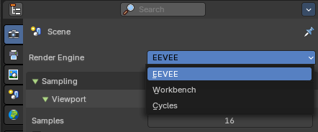
There are three different render engines available. Workbench, EEVEE, and Cycles. This chapter has a focus on the EEVEE render engine.

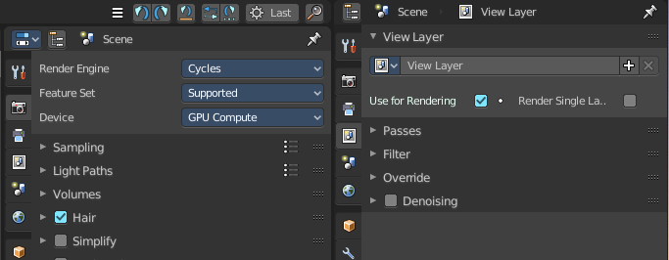
Cycles is a so called offline renderer. It is an unbiased physically correct renderer with some biased adjustments to make it usable for animations.
Cycles can render at the CPU or the GPU.

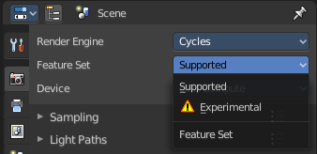
Cycles Feature Set
When you choose Cycles then you will see a new drop down box called Feature set. Cycles has two feature set settings. Supported and Experimental.
Supported means you have all common Cycles settings available.
Experimental means that you have access to some further experimental features of Cycles, which are somehow functional, but are still experimental features. Like Adaptive subdivision. Those features may or may not work proper. Use at own risk!

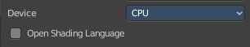
Cycles Device
When you turn on Cuda in the User Preferences then you will get a Device drop down box to choose if you want to render with the CPU or the GPU.

Open Shading Language
When you render with Cycles at the CPU, then you can choose to use the Open Shading Language.

Sampling panel
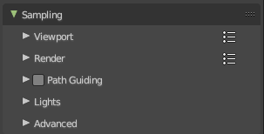
Adjust the samples for Cycles. And enable denoising.

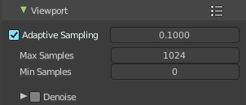
Viewport subpanel
Sampling settings for the Viewport rendering.

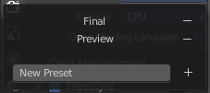
Presets
In the header you will find a Presets menu to choose between presets and define your own presets.

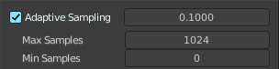
Adaptive Sampling
Automatically redcue the number of samples per pixel, based on estimated noise level.

Adaptive sampling threshold
The noise level step to stop sampling at. Lower values reduces noise at the cost of render time. A value of zero means to use the automatic setting based on number of AA samples.

Max Samples
Maximum samples for adaptive sampling.

Min Samples
Minimum samples for adaptive sampling. A value of zero means to use the automatic setting based on number of AA samples.

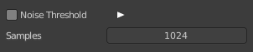
Samples
When Noise Threshold is off then you will see the Samples edit box. Number of samples to render.

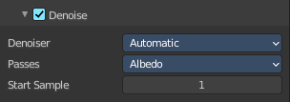
Denoise Sub Subpanel

Use Denoising Checkbox
Activate Denoising.

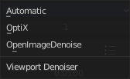
Denoiser

Automatic
Use the fastest denoiser that is available. If OptiX is available then OptiX. Otherwise OpenImageDenoiser.

OptiX
Use the OptiX Denoiser.

OpenImageDenoiser
Use the OpenImageDenoiser.

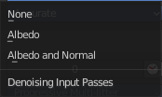
Passes
What input passes to use.

Start Sample
The sample to start denoising at.

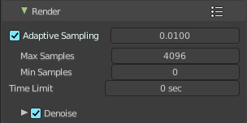
Render subpanel
Sampling settings for the final rendering.

Presets
In the header you will find a Presets menu to choose between presets and define your own presets.

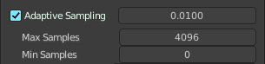
Adaptive Sampling
Automatically redcue the number of samples per pixel, based on estimated noise level.

Adaptive sampling threshold
The noise level step to stop sampling at. Lower values reduces noise at the cost of render time. A value of zero means to use the automatic setting based on number of AA samples.

Max Samples
Maximum samples for adaptive sampling.

Min Samples
Minimum samples for adaptive sampling. A value of zero means to use the automatic setting based on number of AA samples.

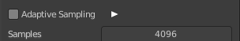
Samples
When Noise Threshold is off then you will see the Samples edit box. Number of samples to render.

Time Limit
When Noise Threshold is off then you will see the Time Limit edit box. Limit the render time. This ends the rendering process after the given time. A value of zero disables the limit.

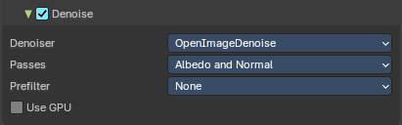
Denoise Sub Subpanel

Use Denoising Checkbox
Activate Denoising.

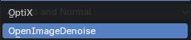
Denoiser

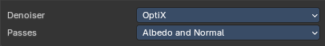
OptiX
Use the OptiX Denoiser.

Passes
What input passes to use.

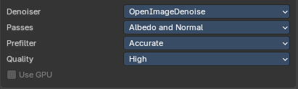
OpenImageDenoiser
Use the OpenImageDenoiser.

Passes
What input passes to use.

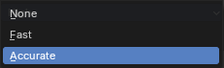
Prefilter
Prefilter noisy guiding to improve quality.

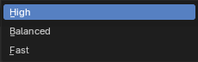
Quality
Overall denoising quality.

Use GPU
Perform Denoising on the GPU.
This property is just active when Cylces device uses GPU and the denoiser is OpenImage Denoise.

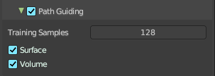
Path Guiding subpanel
Use path guiding for sampling paths. Path guiding incrementally learns the light distribution of the scene. And guides path into directions with high direct and indirect light contributions.

Training Samples
The maximum number of samples used for training path guiding. Higher values results in more accurate guiding at the cost of speed. A value of 0 will continue the training until the last sample.

Surface
Use guiding at surfaces.

Volume
Use guiding inside volumes.

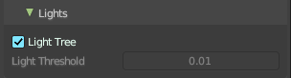
Lights subpanel

Light Tree
When ticked use existing light tree. This will sample multiple lights more efficiently.

Light Threshold
When Light Tree is unticked Light Threshold becomes available. Terminate light samples below this value. This speeds up the rendering at the cost of noise. A value of zero will disable the test. Then all light value will be calculated.

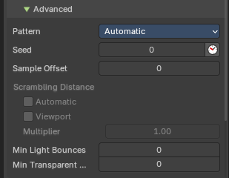
Advanced subpanel

Pattern
Random sampling pattern used by the integrator. You need to turn off Noise Threshold in the Render panel to activate and use the Sampling Pattern.

Automatic
Uses a progressive Multi-Jitter pattern to decide the random sapling pattern used by the integrator. This is a type of noise that allows the renderer to automatically decide the number of samples for each pixel, based on a target amount of noise. This can be very helpful in reducing render times while still maintaining a good level of detail.

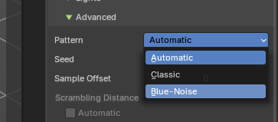
Classic
Uses a Sobol pattern to decide the random sapling pattern used by the integrator. This is a type of pattern that uses a mathematical sequence (the Sobol sequence) to decide the random sampling pattern. It’s designed to cover the most space and ensure that all areas are adequately sampled

Blue Noise
This is a type of noise that is high-frequency. In the context of rendering, it means the noise (or grain) you see in the image appears more like tiny dots scattered around, rather than clumps. This can make the image appear smoother and more pleasing to the eye.

Seed
Seed value for integrator to get different noise patterns.

Animate Seed
The clock icon besides the Seed value. Enable it to get different seed values for animation. Without animated seed you will get visible patterns in animations.

Sample Offset
Number of samples to skip when starting the render.

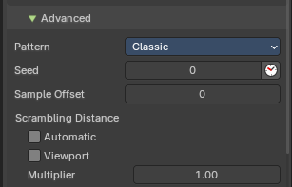
Scrambling Distance
Speeds up the rendering times at the gpu at cost of possible artifacts. You need to turn off Adaptive Sampling in the Render or Viewport panel to activate and use the Scrambling Distance.
Note: This is only available with Classic Sampling.

Adaptive
Instead of a fixed scrambling distance you can use this adaptive method. It is based on the sample count.

Viewport
Also use the scrambling distance in the viewport.

Multiplier
Speeds up the rendering at the GPU by scrambling pixels that are farer away. Lower values renders faster, with less noise – but too low values can lead to artifacts.

Min Light Bounces
The minimum bounces of light rays.

Min Transparent Bounces
The minimum number of transparent bounces.

Light Paths panel
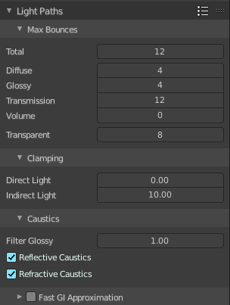
Here you will find all settings regarding light paths.

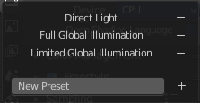
Presets
In the header you will find a Presets menu to choose between presets and define your own presets.

Max Bounces
A sub menu with the Maximum Bounces settings.

Total
Total maximum number of bounces.

Diffuse
Maximum number of diffuse bounces.

Glossy
Maximum number of glossy bounces.

Transmission Bounces
Maximum number of transmission bounces.

Volume
Maximum number of volume scattering bounces.

Transparent
Maximum number of transparency bounces.

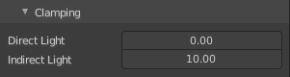
Clamping
A sub menu with the Clamping settings. Clamping will reduce noise at the cost of accuracy.

Direct Light
The maxium value for a direct sample. Zero means disabled.

Indirect Light
The maximum value for a indirect sample. Zero means disabled.

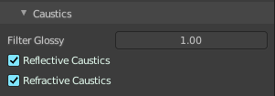
Caustics
A sub menu with caustics and filter glossy settings.

Filter Glossy
When using a value higher than 0.0, this will blur glossy reflections after blurry bounces, to reduce noise at the cost of accuracy. 1.0 is a good starting value to tweak.
Some light paths have a low probability of being found while contributing much light to the pixel. As a result these light paths will be found in some pixels and not in others, causing fireflies. An example of such a difficult path might be a small light that is causing a small specular highlight on a sharp glossy material, which we are seeing through a rough glossy material. In fact in such a case we practically have a caustic.
With path tracing it is difficult to find the specular highlight, but if we increase the roughness on the material, the highlight gets bigger and softer, and so easier to find. Often this blurring will hardly be noticeable, because we are seeing it through a blurry material anyway, but there are also cases where this will lead to a loss of detail in lighting.

Reflective Caustics
Disable reflective caustics. Path tracing supports rendering of caustics with a sufficient number of samples. But in practice it may be inefficient to the point that there is just too much noise.

Refractive Caustics
Disable refractive caustics. Path tracing supports rendering of caustics with a sufficient number of samples. But in practice it may be inefficient to the point that there is just too much noise.

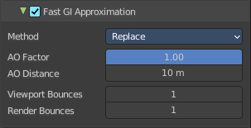
Fast GI approximation subpanel
Approximate diffuse indirect light with background tinted ambient occlusion.
This method provides a fast alternative to full global illumination, for interactive viewport rendering or final renderers with lower quality.

Fast GI Approximation checkbox
The checkbox in the header activates the Fast GI Approximation.

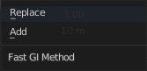
Method
The fast gi method.

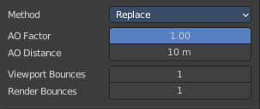
Replace
Replace global illumination with ambient occlusion after a specified number of bounces.

AO Factor
Factor of ambient occlusion blending.

AO Distance
The length of the rays that are used for Ambient Occlusion. Defines how far any other faces gives the occlusion effect.

Viewport Bounces
Use approximate global illumination after this number of light bounces in the viewport. A value of 0 deactivates the feature.

Render Bounces
Use approximate global illumination after this number of light bounces in the rendering. A value of 0 deactivates the feature.

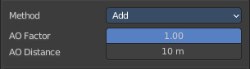
Add
Add ambient occlusion to diffuse surfaces

AO Factor
Factor of ambient occlusion blending.

AO Distance
The length of the rays that are used for Ambient Occlusion. Defines how far any other faces gives the occlusion effect.

Volumes panel

Adjust the volume sampling.

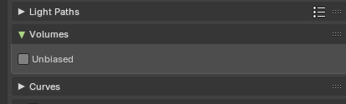
Unbiased
Produces physically accurate results that improve with more samples, but may appear noisy while rendering.

Curves panel
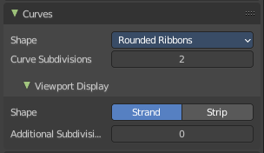
Adjust the settings for Hair particles.

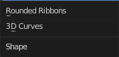
Shape
Choose between the shape 3D Curves and Rounded Ribbon.

Curve Subdivisions
Rounded Ribbons, the number of subdivisions at the curves.

Viewport Display subpanel
How to display the hairs in the viewport.

Shape
The hair shape type. Stand or Strip.

Additional Subdiv
Additional subdivision along the hair.

Simplify panel
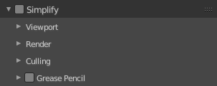

Sometimes you want to simplify the rendering without to loose the already tweaked settings and adjustments. For test renderings for example. Simplify allows you to set global limits on subdivision, shadow samples and more.

Enable
In the header is a checkbox to enable Simplify.

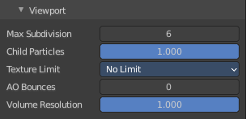
Viewport
This section affects the rendering with cycles in the Viewport.

Max Subdivisions
Limit the number of maximum subdivisions.

Child Particles
Limit the number of child particles.

Texture Limit
Automatically scales down textures to the chosen value.

AO Bounces
Limit the number of Ambient Occlusion Bounces.

Volume Resolution
Simplify volumes by adjusting volume percentage of volume objects in viewport.

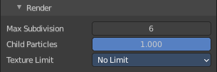
Render
This section affects the final rendering.

Max Subdivisions
Limit the number of maximum subdivisions.

Child Particles
Limit the number of child particles

Texture Limit
Automatically scales down textures to the chosen value.

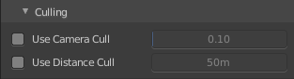
Culling
Contains Culling settings. Culling means that the affected geometry is excluded from calculation.

Use Camera Cull
Allow objects to be culled based on the Camera Frustum. Frustum is the region of the 3D space that gets displayed by the camera, the field of view.

Camera cull margin
The margin for the camera space culling.

Use Distance Cull
Allow objects to be culled based on the distance to the camera.

Distance
The distance after which the objects gets culled away.

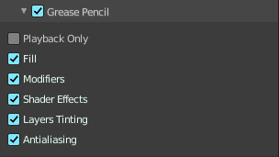
Grease Pencil

Playback Only
Simplify the grease pencil strokes only during playback.

Fill
Display Fill strokes in viewport.

Modifiers
Display Modifiers.

Shader Effects
Display Shader effects.

Layers Tinting
Display layer tint.

Antialiasing
Use antialiasing to smooth stroke edges.

Motion Blur panel
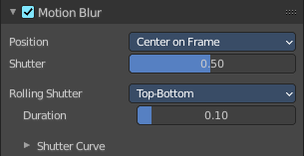
Enable Motion Blur and adjust the settings.
Each object has also its own settings to control motion blur. These options can be found in the corresponding Object tab of the Properties editor.

Enable
In the header is a checkbox to enable Simplify.

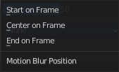
Position
Controls at what point the shutter opens in relation to the frame.

Shutter
Time between frames over which motion blur is computed. Shutter time 1.0 blurs over the length of 1 frame, 2.0 over the length of two frames, from the previous to the next.

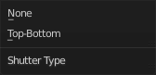
Rolling Shutter
Enable Rolling Shutter.

Duration
With method Top - Bottom only. Controls balance between pure rolling shutter effect and pure motion blur effect. With zero being no rolling shutter and one being all rolling shutter.

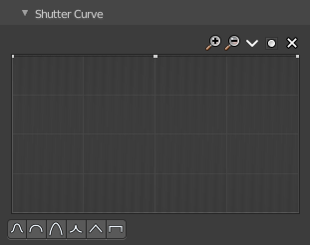
Shutter Curve
Sutter curve is a sub menu wAdjust a curve for the shutter effect.

Navigation elements
The navigation elements at the top are described from left to right.

Zoom in and out
The two buttons with the magnifying glass at it zooms in and out in the curve window.

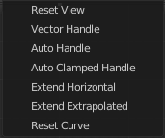
Tools
Tools is a menu that contains some curve related tools.

Reset View
Resets the curve windows zoom.

Vector Handle
Set handle type to Vector.

Auto Handle
Set handle type to Auto.

Auto Clamped Handle
Set handle type to Auto Clamped.

Extend Horizontal
Causes the curve to stay horizontal before the first point and after the last point.

Extend Extrapolated
Causes the curve to extrapolate before the first point and after the last point, based on the shape of the curve.

Reset Curve
Resets the curve to the initial shape.


Use Clipping
Clipping options. Set up clipping for the stroke.

Delete Points
Deletes selected curve points.

X and Y values
The coordinates of the currently selected curve point.

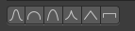
Presets
At the bottom you can find some curve presets.

Film panel
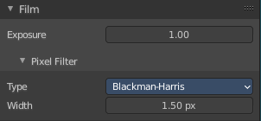

Exposure
Exposure can be used to change the brightness of an image. Different then the Exposure option found in the Color management panel this exposure option works is on the data while the Color management exposure is on the view.

Pixel Filter
The Pixel Filter randomly changes the coordinates of every sample with the given distribution. For example: When the Sobol Sampling Pattern samples near the edge of the pixel, the neighboring pixel might be lit instead with a rather high probability. Pixel filter is used to get rid of aliasing on the sharp edge of very bright objects, like mesh lights.

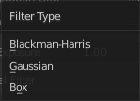
Type
Choose the pixel filter type.

Width
Adjust the pixel filter width.

Performance panel
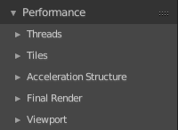
Settings to influence the render performance.

Presets
Performance presets can be applied to quickly configure Cycles.

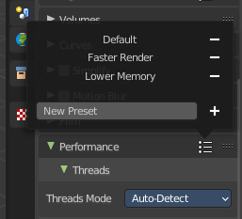
Default
This preset are the default cycles settings.

Faster Rendering
This preset is dedicated to speed with higher memory usage. This may be more unstable due to hardware limits.

Lower Memory
This preset is dedicated to lower memory. This may cause longer renders.

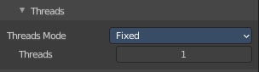
Threads
With threads, you are able to to assign as many cores as you need from your CPU as dedicated resources. Default is Auto-Detect.

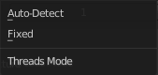
Mode

Auto-detect
Automatically chooses the amount threads to match the number of logical processors on your computer.

Fixed
Manually choose the amount threads to use for rendering.

Threads
Just active when you choose Fixed. Number of threads that you want to use.

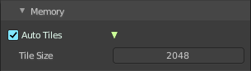
Memory

Auto Tiles
Automatically render high resolution images in tiles to reduce memory usage. Tiles are cached to disk while rendering, to save memory.

Tile Size
The tile size for the tiles.

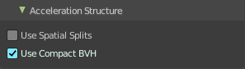
Acceleration Structure

Use Spatial Splits
Spatial splits improve rendering performance in scenes with a mix of large and small polygons. The downsides are longer BVH build times and slightly increased memory usage.

With CPU rendering:

Use compact BVH
Use a compact BVH code structure that uses less ram. This option renders slower.

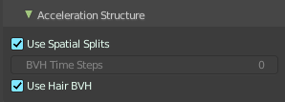
With GPU rendering:

BVH Time Steps
Is just active when Spatial Splits is off. Split BVH Primitives by this number of time steps. This speeds up rendering, but requires more memory.

Use Hair BVH
Use a special type of BVH for rendering hair. The bounding boxes are not axis aligned allowing a spatially closer fit to the hair geometry. Disabling this option will reduce memory, at the cost of increasing hair render time.

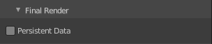
Final Render

Persistent Data
Keep image data in memory after rendering, for faster re-renders at the cost of extra memory usage when performing other tasks in Blender.

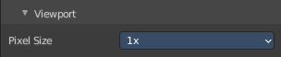
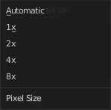
Viewport
This settings is for rendering in the Viewport.

Pixel Size
Pixel Size for Viewport Rendering.

Bake panel

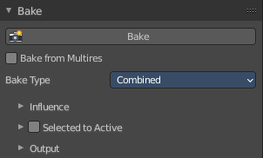
Texture baking is the process to bake specific informations from one object into the texture or the vertex colors of another object. Ambient Occlusion. Or a Normal Map for example.

NOTE
Baking into textures requires to have a working UV mapping and a texture at the target object!

How to use: Select the source object where you want to bake from, hold down Shift, select the target object where you want to bake to, so that both objects are selected. Adjust the settings to your needs. Then hit the Bake button.

NOTE
The Bake panel is visible in all Modes. But you have to bake in Object Mode.

Settings for all Texture types
Most settings in the Bake panel are available for all texture types.

Bake Button
Start the bake process.

Bake from Multires
Bake directly from multi resolution object.

Bake Type
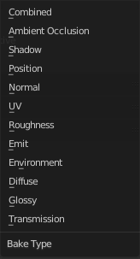
Bake Mode is a drop-down box to choose what type of information you want to bake from the source object into the texture or the vertex colors of the target object.
You can bake Subsurface, Transmission, Glossy, Diffuse, Environment, Emit, UV, Normal, Shadow, Ambient Occlusion and Combined.

Combined
Bakes the full rendering, means materials, textures, lightning, into the texture of the target object. Except Specularity.

Ambient Occlusion
Bakes ambient occlusion as specified in the World panels. Ignores all lights in the scene.

Shadow
Bakes the Shadow into the texture of the target object.

Position
Bake out a position map. Position maps stores the distance from the floor. Which allows to add a dirtmap above some ground for example.

Normal
Creates a Normal map by using the normals of the source object, and baking them as colors into the texture of the target object.

UV
Bakes colors of materials and textures only, without shading.

Roughness
Bakes the Roughness of a material into the texture of the target object.

Emit
Bakes the Emission or the glow color of a material into the texture of the target object.

Environment
Bakes the Environment texture into the texture of the target object. As seen from the center of the object.

Diffuse
Bake the diffuse texture of the source object into the texture of the target object.

Glossy
Bakes the Glossy Passes of a material into the texture of the target object.

Transmission
Bakes the transmission Passes of a material into the texture of the target object.

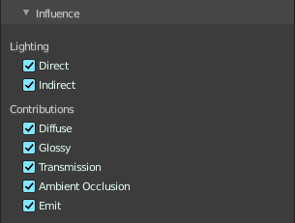
Influence Sub panel
Adjust what data contributes to the bake process. The items are self explaining.
The content changes, dependent of what type you want to bake.

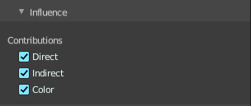
Glossy, Diffuse

Direct
Add direct Light.

Indirect
Add indirect Light.

Color
Add Color.

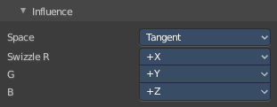
Normal

Space
A drop-down box to chooses the Normal Space to use.

Swizzle
Axis to bake in red, green and blue channels.

Combined

Direct
Bake directly from Multires mesh.

Indirect
Normalizes without using material settings.

Diffuse
Bake with Diffuse.

Glossy
Bake with Glossy.

Transmission
Bake with Transmission.

Subsurface
Bake with Subsurface.

AO
Bake with Ambient Occlusion.

Emit
Bake with Emit.

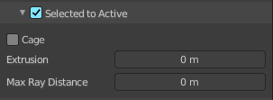
Selected to Active
The usual way to bake is first select the Source Object, where you want to bake from, hold down Shift, select the target object where you want to bake to, so that both objects are selected. Then hit the Bake button. That's Selected to Active.

Extrusion
Inflate the active object by the specified distance for baking.

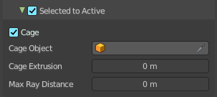
Cage
Cast Rays to active object from a cage. A value of zero means unlimited ray length.

Cage Object
Pick an object to use as a cage. Usually you create this cage object by duplicating the original object, and extrude out the faces along their normals until they fully include the original object.

Ray Distance
Distance to use for the inward ray cast when using Selected to Active.

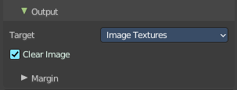
Output Sub panel

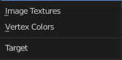
Target
To what target to bake. You can bake to images or you can bake to the vertex colors of the mesh. Note that baking to vertex colors has no further options.

Clear Image
Clear clears the target image before baking.

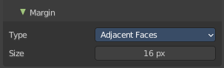
Margin sub subpanel
Adjust the margin width.

Type
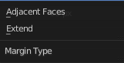
The margin type.

Adjacent Faces
Use pixels from adjacent faces across UV seams to create the margin.

Extend
Use the pixels at the inside of the border UV seams, and extend from there to create the margin.

Size
The size of the margin around the UV patches.

